Application Software

Application software is a computer program that performs a specific function. be it educational, personal, or business. It is also known as an end-user program or a productivity program. Each application is designed to assist users with a particular task that may be related to creativity, productivity. or communication. Application software programs are specific in their functionality and perform the job they are designed to do. The primary goal of every application software is to simplify an operation and help users get their tasks done effortlessly.

Today, we have a plethora of high-end application software at our disposal that defines how we live our lives and accommodate our ever-evolving requirements. Widely used application software includes office productivity suites, data management software, media players, and security programs. The common apps we see on our smartphones are also examples.

Examples of Application Software

Be it completing your tasks. jotting down notes, completing your online research. setting the alarm, keeping an account log, or even playing games, there are explicit application software programs that can help you out. Application software programs are designed to perform specific tasks, simplify workflows, and improve team communication. The most common examples of applications used by millions daily are listed below.

1.A suite of Microsoft products such as MS Office, PowerPoint, MS Word, Excel, and Outlook

2. Internet browsers like Google Chrome, Safari, Firefox, etc.

3. Graphics and design software such as Adobe Photoshop, CorelDraw, and AutoCAD

4. Real-time online communication tools like Skype. Hangouts, Google Meet, Zoom, and Whatsapp.

5. Multimedia and music streaming software such as MX Player, VLC Media Player, Spotify, Pandora, etc.

6.Project management software like Asana, Zoho, Slack, Forecast, etc

Things to Look For In An Application Software

With numerous application software available in the market, some come pre-built with features you can customize. However, sometimes you'll have the chance to build a new application with your desirable features. Unfortunately, the reality is that no application software is the same. Many are subpar at best, and some completely inept at worst. Therefore, you must ensure that the application software meets all your requirements and is helpful

Now, the question is how to judge a good application software. Here are six fundamental characteristics that a good application must satisfy

Which qualities must have application software?

1.User Experience

2. Performance

3. Security

4. Accessibility

5. Scalability

6. Customer Support

Functions of Application Software

Application software programs are designed to execute a large variety of functions. The functions can vary depending on the users' requirements. Irrespective of the industry or business domain, application software can be built to serve a specified purpose. Here are a couple of examples.

1. Data analysis and information management

2. Document manager

3. Emails, text messaging, audio and video conferencing

4. Graphics, animations, and video development

5. Accounting, payroll and finance management.

6. Project management

7. Resource (ERP and CRM system) and HR management

8. Software for healthcare management

9. Business project management

10. LMS and eLearning software

What is the difference between System Software and Application Software?

Software is basically a set of instructions or programs to carry out a task. They can be classified into two types-System Software and Application Software. Both are software programs designed to instruct and interact with the system or user to perform specific tasks. However, both the software have considerable differences in terms of their design and purpose. Let's delve into their key differences.

System Software

1. System software is designed to control and manage the

hardware and other resources of the system.

2. System software is pre-installed with the operating system.

3. System software is commonly referred to as general-purpose software.

4. It acts as an interface between application software and the system.

5. Developed in low-level language or machine code that is more compatible with the system hardware.

6. System software can run independently

7.System software is commonly referred to as general-purpose software

8. It acts as an interface between application software and the system

9. Developed in low-level language or machine code that is more compatible with the system hardware:

10. System software can run independently.

11. Programming of system software is complex

12. It acts as a platform and runs in the background. O Performs primary functions of process management, memory

Application Software

1. Application software is designed to accomplish tasks for a specific purpose based on user requests

2. Application software is third-party software that can be downloaded and installed according to user needs

3. Application software is commonly referred to as specific purpose software

4. Hosted on the platform, which is provided by the system software

5. Programmed in high-level languages such as C++, Python, or Javascript

management, task scheduling, hardware installation, etc.

Users don't interact with system software.

O System software is mandatory for a system to function.

O Examples: compiler, assembler, debugger, driver, etc

downloaded and installed according to user needs.

Application software is commonly referred to as specific- purpose software.

Hosted on the platform, which is provided by the system software.

Programmed in high-level languages, such as C++ Python, or Javascript

Application software cannot run independently and need the

presence of system software

Programming of applications is comparatively simpler Runs in the foreground and performs a task based on user

requests.

Performs user-specific tasks for which it is designed

User interacts with the application software.

Application software is not mandatory and the system can

function without it

Examples word processor, web browser, media player.

photoshop, etc

Know the Terminology Differences

App vs Application

App: An app is a software that is built for a single purpose and performs a sole function for users. It is specifically designed to run on mobiles and tablets. They can also run on desktops. provided the OS supports those apps. Some popular examples of apps are Open Office. photo-shop, browsers. WhatsApp. Angry Birds, etc.

Application: An application is a software primarily intended to perform a variety of functions for users. It offers services in areas like automation, data processing, and integration. Applications are designed to run only on desktops or laptops but not on mobiles and tablets. They are likely to be larger packages with multiple functions. Some examples include Microsoft Office, Adobe Photoshop, VLC Player, etc.

On-premise Application Software vs Hosted Application Software

On-premise: On-premise was the traditional method businesses used software. With on-premise software. you purchase the software and license, install it on your own server, and maintain it yourself. You need to own your servers internally and complete all the back-ups and upgrades to the software. On-premise software provides increased security since you have total control over the updates and software changes.

Types of Applications Software

As the world is an era of digitalization, every sphere of business requires application software. The use of the software is rampant across every domain, including banking, healthcare, education, retail, travel, logistics, etc. Picking up the right application software for your specific needs improves function and efficiency. Understanding the different types of application software will help you save cost. time: and resources, enhance productivity, and improve decision-making. Application software can be broadly classified into General Applications, Business Applications, and Custom Developed Applications.

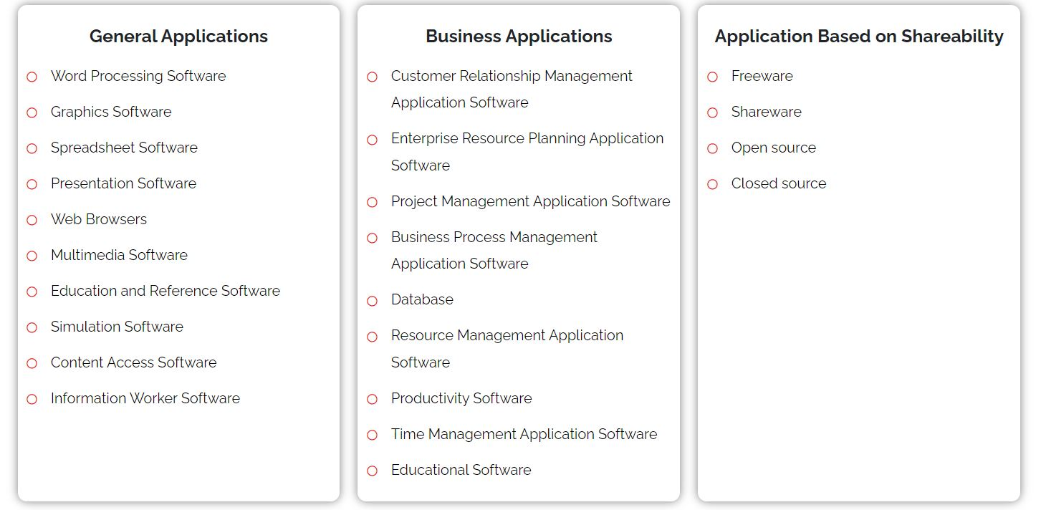

Exam Questions

1.Definition and types application software

2. Examples of application software

3. Which qualities must have application software

4. Functions of Application Software

5. What is difference between System Software and Application Software

[Click for more](https://www.confianzit.com/cit-blog/types-of-application-software/)

Contents

Examples of Application Software 1

Which qualities must have application software? 1

Functions of Application Software 2

What is the difference between System Software and Application Software? 2

System Software 2

Application Software 3

App vs Application 4

On-premise Application Software vs Hosted Application Software 4